DYNAMICALLY ALLOCATION OF MEMORY FOR TWO ARRAYS

This code prompts the user to enter the length of the arrays, then dynamically allocates memory for two arrays (`a` and `b`) of that length. It then asks the user to enter elements for both arrays. Finally, it calculates the sum of the corresponding elements from both arrays and prints the resultant array.

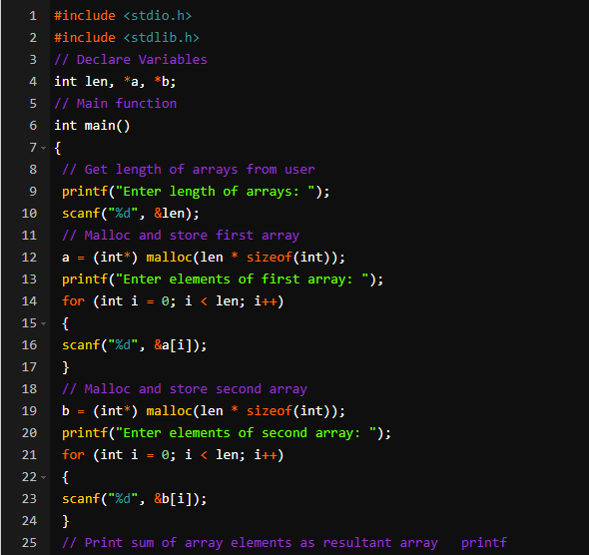

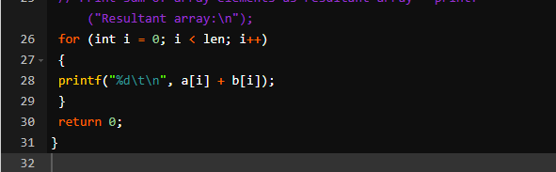

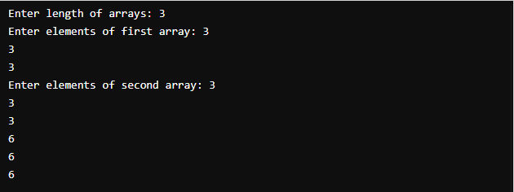

SCOPE OF VARIABLE

Different types of variable in c

1. Local variable

A local variable is declared inside a function block, may it be main() function or any user defined function. The normal variable declared in any C program without adding any keyword behind it while the declaration of the variable is called as local variable

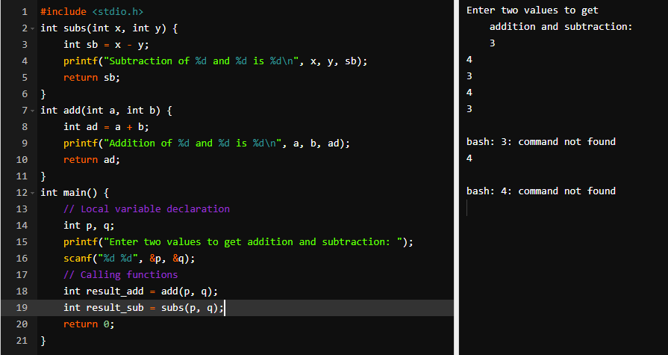

1. Global variable.

Explanation :

Global variable is declared at the start of the program before declaring any function in the program. It is declared just after including the required libraries/headers. It is not declared inside any function block. Advantage of global variable over local variable is that a global variable is accessible in any function block of the program , may it be user defined function or the main() function. Also its value is dynamic and thus it can take up new values every time it is used in a function.

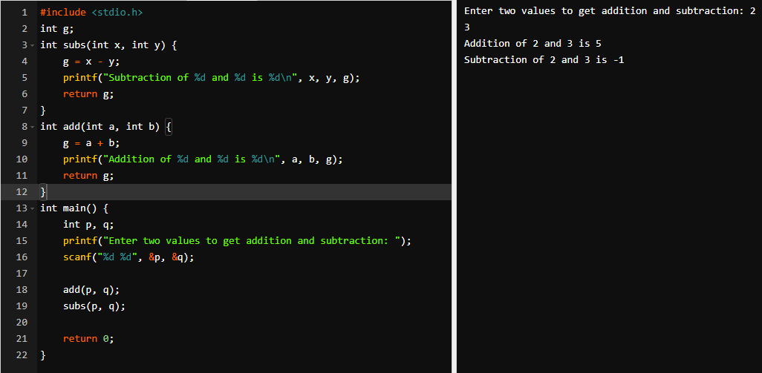

1. Static variable.

Explanation :

Static variable does not change its value once assigned. It is mainly

declared inside a function block.

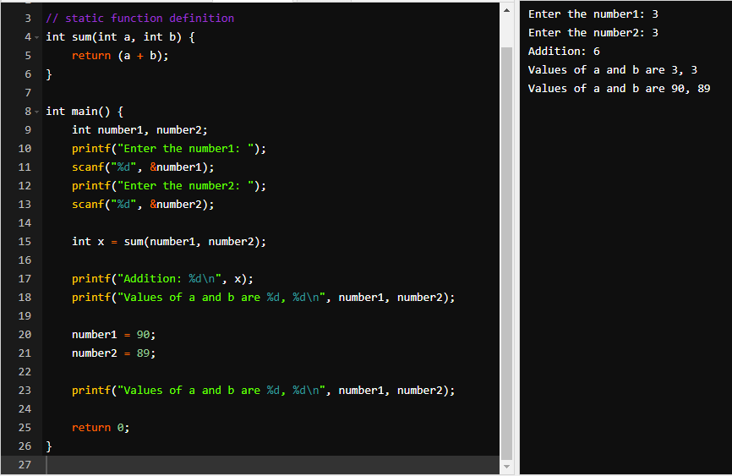

1. Automatic variable.

Explanation :

Automatic variable is similar to local variable. However we nned to add the keyword ‘auto’ before the declaration of a variable inside a function block. By doing so, the compiler returns a garbage value if that variable is printed before assigning any value to it.

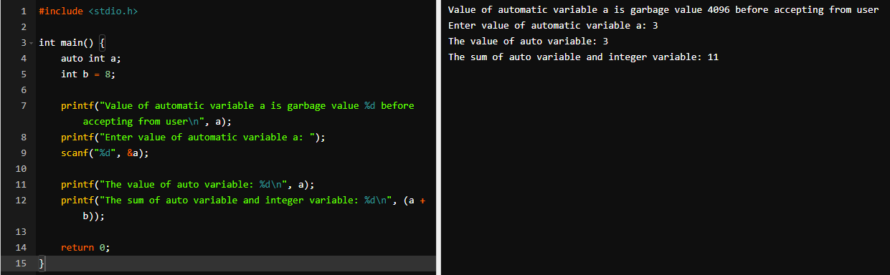

External variable.

Explanation :

External variable is similar to global variable. It is declared outside the function block and is declared with keyword ‘extern’. This variable can now be accessed via any C program file having same location as the file that contains this external variable and can perform operations as well on this variable without declaring it in other file. For this we first need to create a file with extension ‘.h’ and then declare extern variable here. Then this file is to be attached to the C program file in which this external variable is to be accessed. It is attached by including it as a header file along with other libraries/headers with syntax #include “name.h”.

